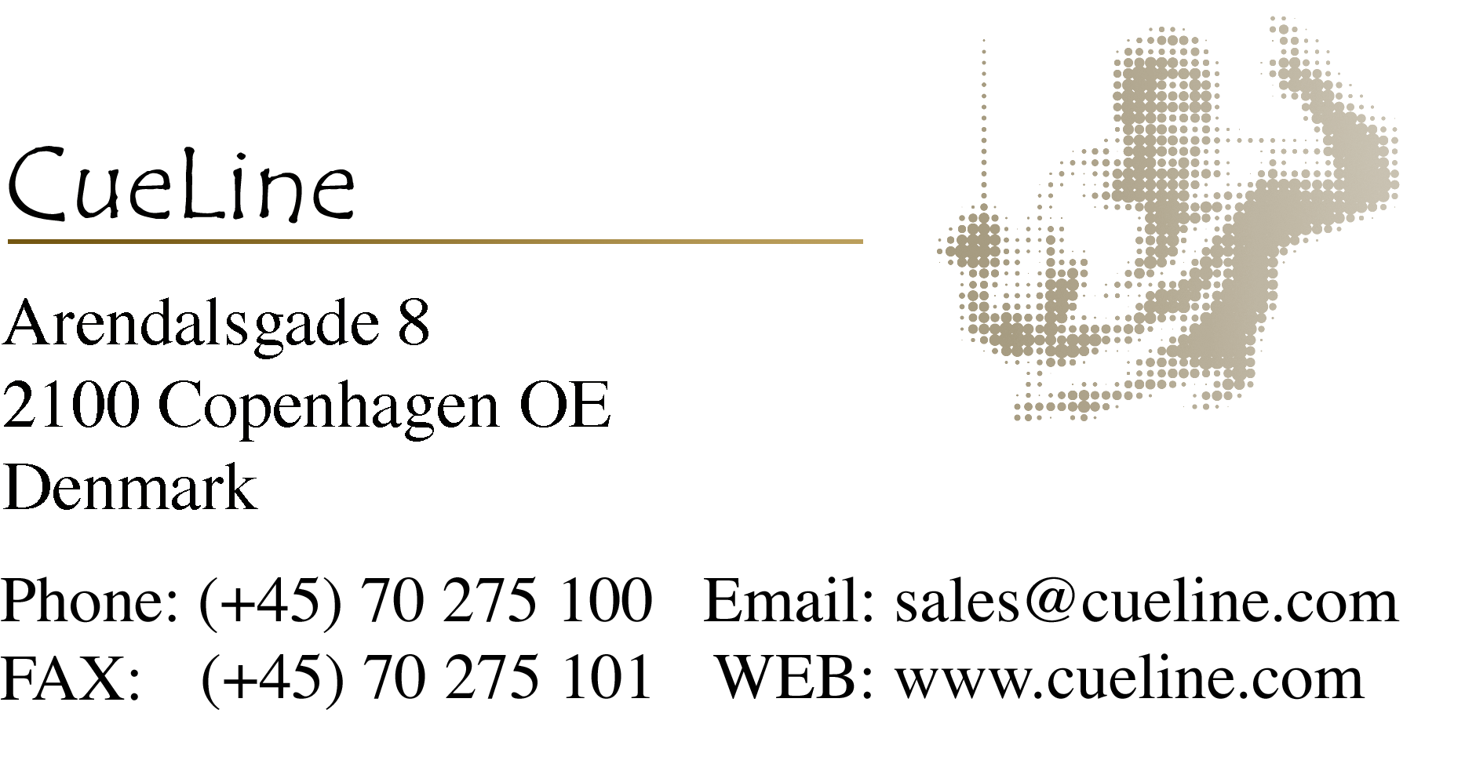

Dear Film Music Professional,
Whether you are an experienced user of Picture cueing or a novice in this particular field this should be of interest to you. Picture Cueing has been used in Hollywood since the 1930s and to this day it is still used in 80% of all Hollywood films. There is a good reason for this! It decreases the recording time and heightens the impact of the score. All it takes is a ProCue 1m1 unit and a MIDI sequencer or some dedicated music editing software.

How can Picture Cueing be an advantage for the film composer / conductor?
By means of visual cueing the film conductor is guided easily and with incredible precision through the recording of the film score, so that the timing is accurate and at the same time does not infringe on the conductor’s concentration more than absolutely necessary.
The visual cues that can be seen on the screen correspond to the cue points in the conductor’s score thus making it possible for the conductor to know exactly where he is at without necessarily depending on metronome clicks.

If the music requires the use of metronome clicks (such as cues with many hits or rhythm steady cues)
Visual cues are employed to convey the form of the music. For example, the conductor will be cued to the first click of the count in, the first beat of bar 1 and all the following bar lines, meter changes, tempo changes, hits and endings. This enhances the conductor’s overview as well as enabling him to concentrate even more on the performance of the music.

When you want rubato conducting:
Here the visual cues are an excellent and musical method of synchronizing the orchestra to the movie because the system allows the conductor to conduct “rubato” (multiple, slight tempo variations according to personal taste) and in the next instant allowing the orchestra to minutely hit any desired frame – commonly referred to as a hit.

What is picture cueing?

Streamer: A vertical bar that moves horizontally across the screen from left to right. When the bar exits the right side of the screen a punch (a hole) appears in the picture where the hit is to occur. The streamer gives the conductor adequate time to guide the orchestra toward the hit.

Flutter: A quick series of blinks (punches or holes) that indicate where the musical bar lines are placed in relation to the film.

Punch: A white, circular blink following each streamer.

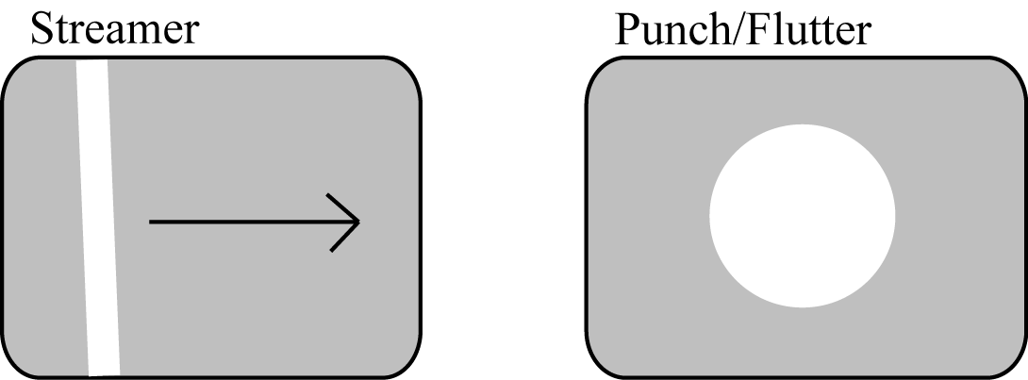

Up until 1988 the visual cues were prepared as physical holes and lines on a work print of the film making it difficult to make quick corrections. Today ProCue 1m1 is used to generate the visual cues in real time.

Here is a brief description of the process from spotting the film to recording.

The Movie:
When the movie has been through final cut each frame has been allotted a time code.
The time code consists of “hours: minutes: seconds: frame” (European video formats run at 25 frames per second) For example: 00:11:44:12 is the time code for frame number 12 that is 44.5 seconds into the 11th minute of the movie.

The spotting session:
A spotting session is a meeting between the composer, director and maybe a music editor where in and out times for every music cue in the movie are decided.

The following is an example of a cue’s in and out times with picture description.

Music Cue 56, reel 3

Time code Description
In 03:15:38:03 Shark’s arm starts to grab Joe
Out 03:16:28:22 Fly is hit by the claw (black out): music out.

Cue sheet
After deciding where the movie will feature music, the music editor/composer will prepare a detailed cue sheet for each music cue where the musically important events are noted in relation to the time codes.

Cue sheet for Music Cue 56, reel 3  (Prepared in CUE for MAC)  To the right can be seen a cue sheet prior to the music editor’s /composer’s calculations.  The numbers in the right column indicate which clicks or beats the notated events/frames will hit on. For example, frame 03:15:38:15 (shark grabs Joe) is reached at click 2.06. The “.06” is one hundredth of a beat. To hit precisely on one frame it is necessary to adjust the tempi throughout the entire cue so that the selected frames will appear as closely as possible to a down beat.  Frame 03:16:26:04 (Close up of crab, Big and Ugly) appears on click 106.69 which corresponds to a triplet-eighth note before beat 107. If the frame falls on a triplet eighth before a beat and the music has an accent on beat 107 it will not be perceived as being simultaneous, and therefore not considered a hit. | 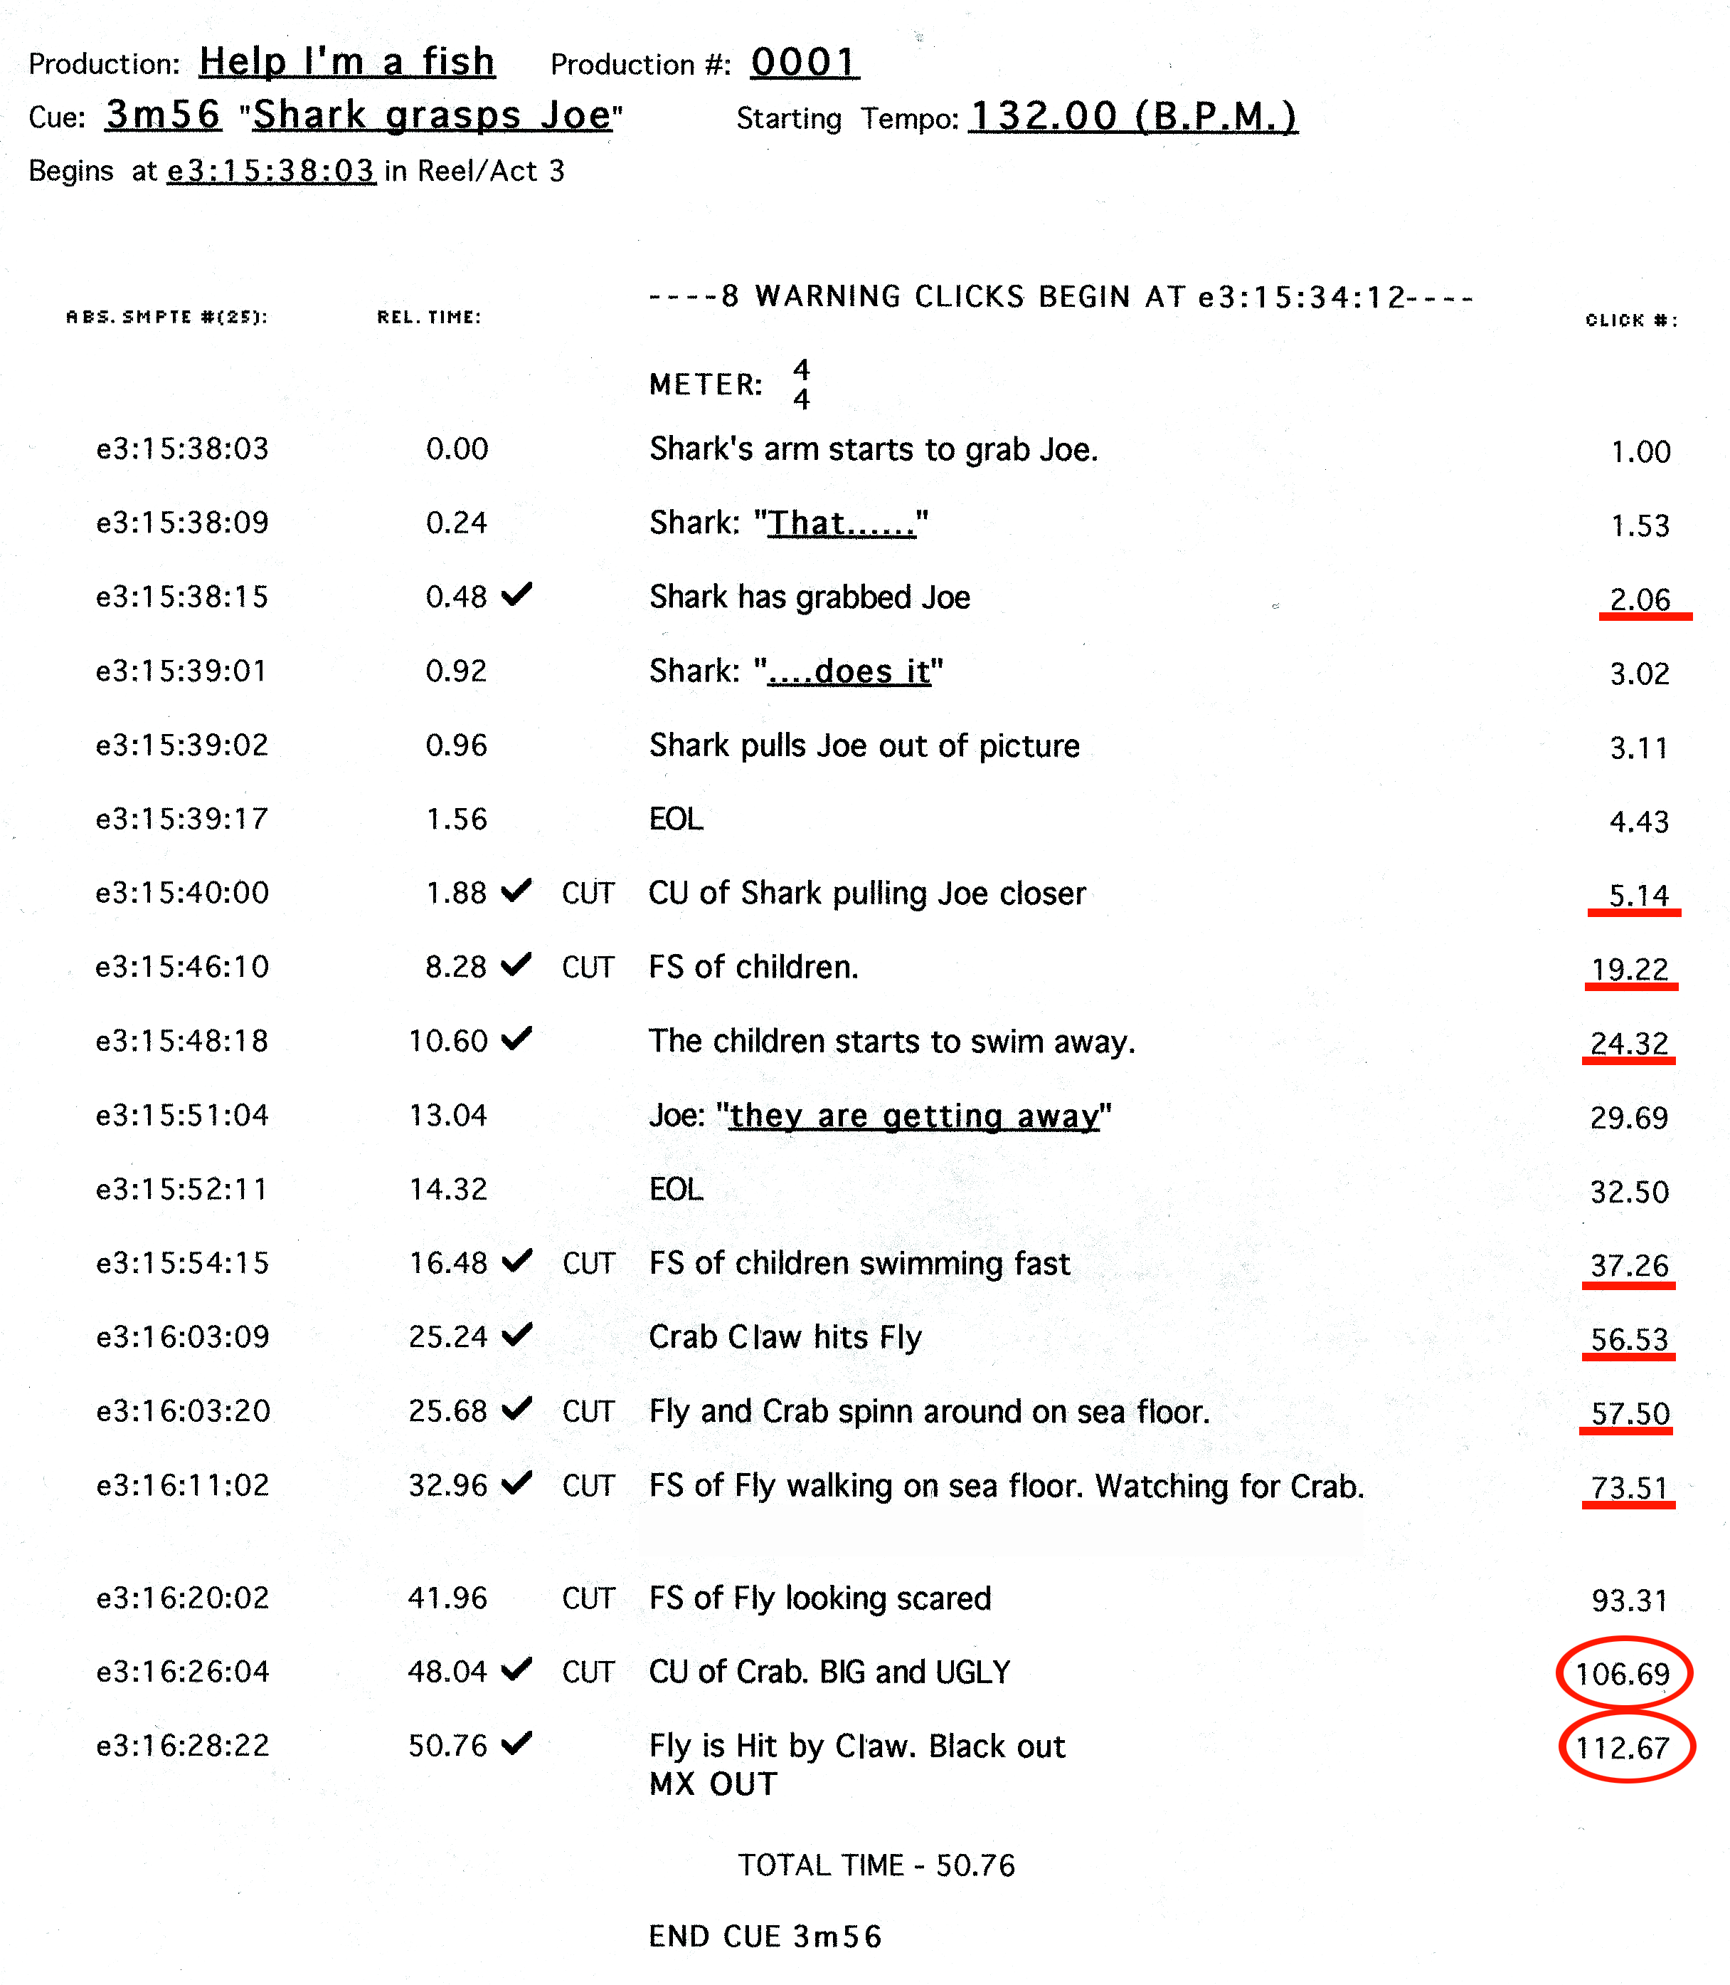

Using the correct computer application makes it possible to find an ideal tempo so that the music hits the most cues. Following this, slight tempo changes between the hits are made so that all desired hits fall on a down beat in the music. This illustrated in the cue sheet to the right. Notice that frame 03:16:26:04 now falls on beat 106.03 – which is definitely a hit. Likewise, 03:16:28:22 falls exactly on click 112.  The composer receives/uses the cue sheet after the calculations have been made. The time signatures are adjusted during the composition since, due to musical reasons, it is preferred that the hits fall on a down beat. See below. | 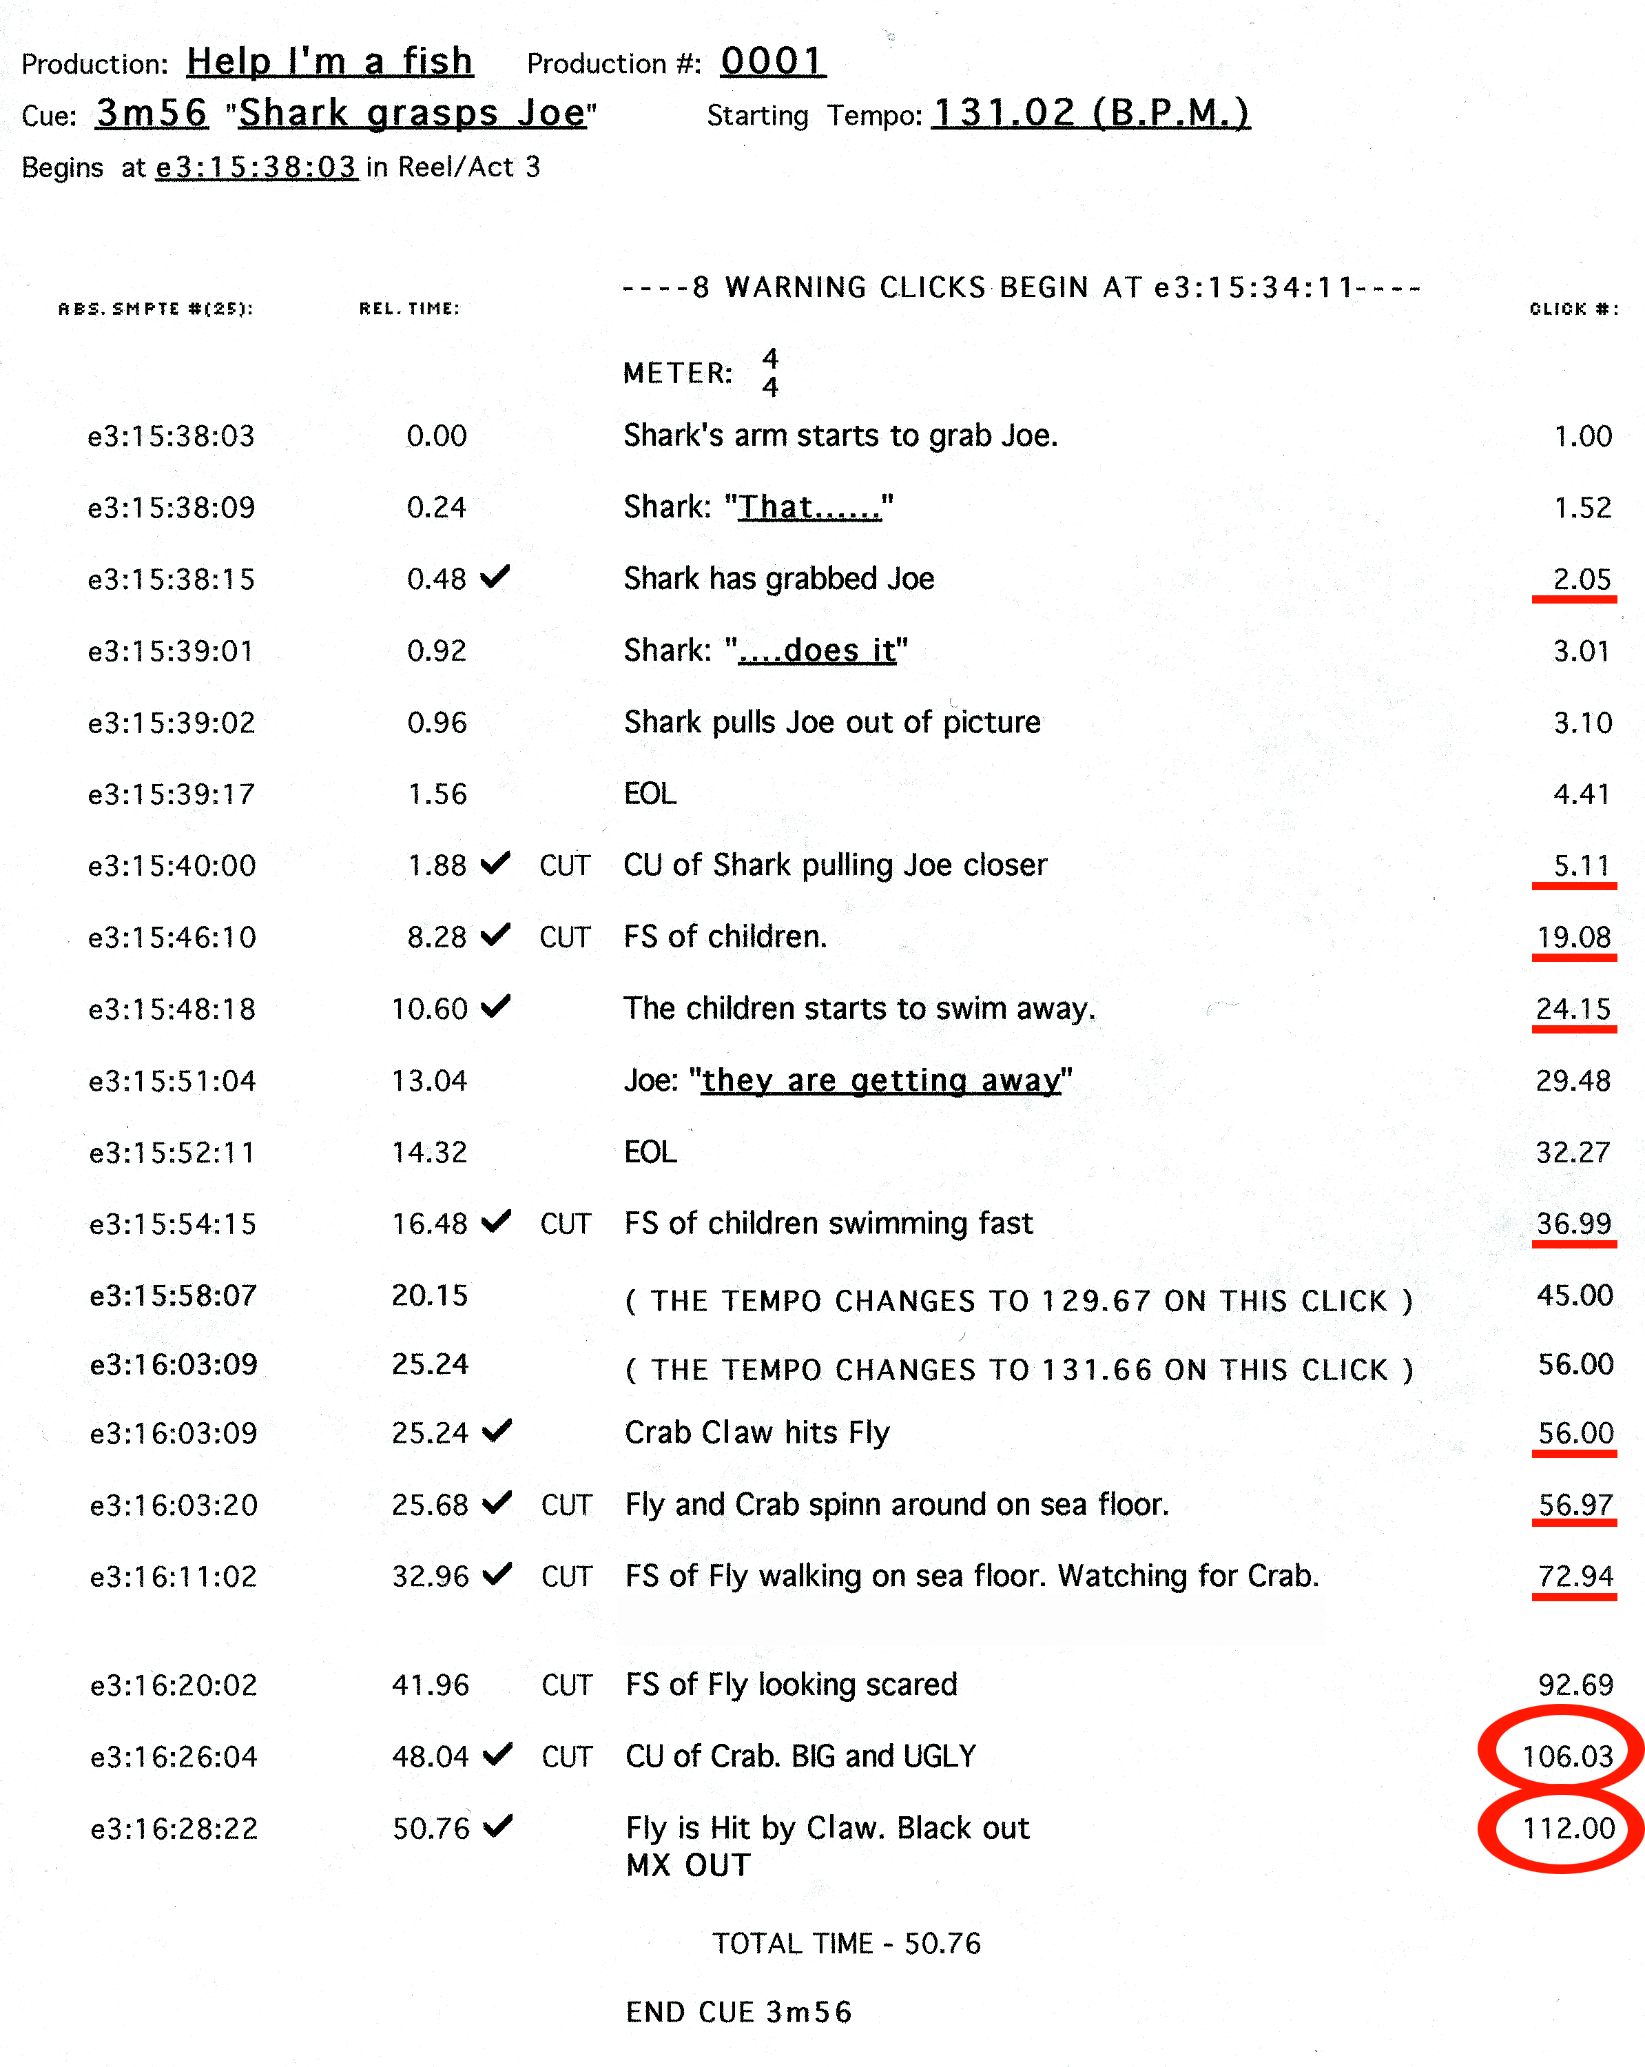

The Score
In the conductor score marks are inserted that correspond to the visual cues that can be seen during playback. It is the conductor’s task to conduct the orchestra so that the marks in the score fall on the same time as the corresponding visual cues that are on the screen. Notice that the composer has made bar 25 into a 3/4 bar so that it will hit click number 106 on a down beat, and bar 27 is made into a 2/4 bar so that it can hit click number 112 on a down beat.

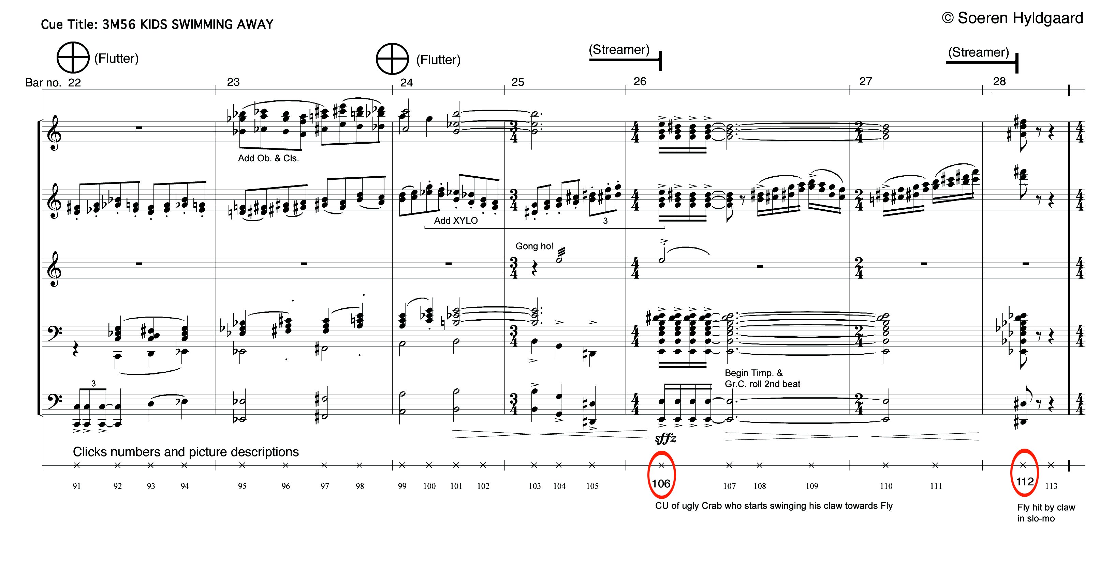

Preparation of Picture Cueing
If the measure layout and tempi are defined in a MIDI sequencer file,the only step missing is the insertion of the MIDI notes that control at which point the ProCue 1m1 is to generate the visual cues for the conduc-tor. If the measure layout and tempi were calculated in software such as Cue or Auricle and the score was composed without using a MIDI sequencer, the remaining step is to tell Auricle or Cue where streamers and flutters are wanted. At www.cueline.com there is a description available of how to control ProCue 1m1 with Cubase, Logic, Performer/DP. The controlling software should be in sync with the movie and simultaneously controlling ProCue 1m1 during the recording session. This makes for easy changes if the conductor needs something not already prepared. For example clicks instead of streamers from bar 24 to bar 56.

Some customers and users
Composers: | Don Davis | Joe E. Rand
John Williams | John Debney | Jonathan Karp
John Barry | Anne Dudley | Dina Tuchner
Jerry Goldsmith | Michael Nyman | Michael Connell
James Horner | Laurence Rosenthal | Stephen M. Rowe
Danny Elfman | Mark Shaiman | Ellen Segal/ Segue Music, Inc.
James Newton Howard | Bennett Salvay | Ken Wannberg
Alf Clausen | Christopher Young
David Newman | Joel McNeely | Educational Institutions:
David Arnold | Michael Nyman | UCLA
Lee Holdridge | Ray Ellis | Berklee College Of Music
Hummie Mann | T. Bone Burnett
Howard Shore | David Mansfield | Studios:
Shirley Walker | John Ottman | Abbey Road, London
Graeme Revel |  | Air Studios, London
Marco Beltrami | Music Editors: | Capitol Records, LA
Michael Kamen | Tom Carlson | Fox Newman Stage, LA
Rachel Portman | Clifford Kohlweck | MGM/Sony, LA
Bruce Broughton | Chris Cozens | O´Henry, LA
Teddy Castellucci | Andy Glen | Paramount, LA
Patrick Doyle | Ken Hall | The Warner Bros. Stage, LA
Edward Shearmur | Jim Henrikson | Todd AO, Studio City CA
Clint Mansell | Suzana Peric | Schnee Studios, Burbank CA

Some film credits:
Dragnonfly | Signs | Jurassic Park III
K-PAX | Enough | Joyride
Shipping News | A Beautiful Mind | Monkeybone
Treasure Planet | 8 Crazy Nights | Kingdom Come
Harry Potter | Tomb Raider | Bedazzled
Lord of the rings | Swordfish | Mists Of Avalon
The Devine Secrets of the Ya Ya | America’s Sweethearts | Emperor’s New Groove
Sisterhood | Atlantis | The World Is Not Enough
Ice Age | Chocolat | The Claim
Death to Smoochy | McCools | The Musketeer
Life Or Something Like It | Vertical Limit | What's The Worst That Could Happen
Minority Report | The Simpsons | Little Nicky
Panic Room | The Animal | My Napoleon
The Scorpion King | Enemy At The Gates | Boycott
Star Wars - The Clone Wars | Long Time Dead | Jeepers Creepers
Eight Legged Freaks | Family Life | Band Of Brothers
Mr. Deeds | A.I. | 102 Dalmatians
Murder By Numbers | Unbreakable | Proof of Life
Men In Black II | Mysterious Island | Nutty Professor II

Chris Cozens (Music editor/ London) wrote:

“The phrase "plug and play" is sometimes overused. However, in the case of the ProCue 1m1 - the term is entirely justified. It works exactly as expected straight out of the box. The 'streamers' are bright and wide and therefore unmissable on screen and the 'clicks' are adaptable to suit all users. The 'sync-pop' is a great added bonus. The fact that the ProCue 1m1 is programmable makes the application compatibility for this unit limitless”.

Sincerely yours,

Thomas Lester
Manager, Cueline ApS

